Application Deployment _Trend

Docker: Setup and clone
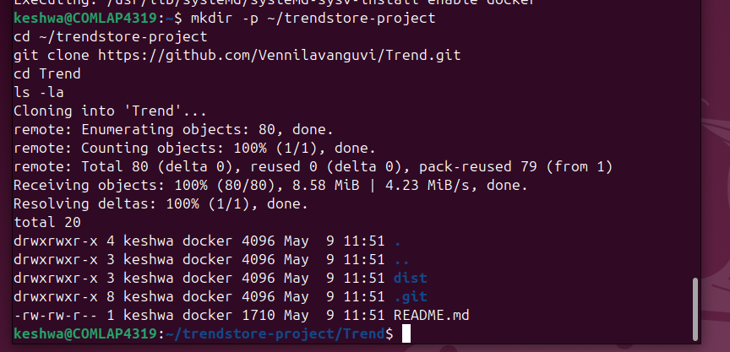
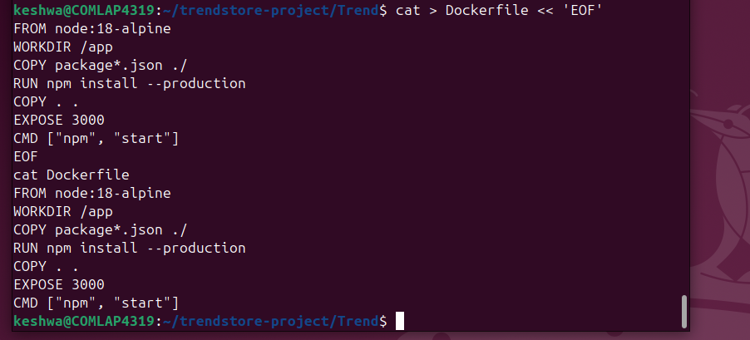
cat > Dockerfile << 'EOF'
FROM nginx:alpine
COPY dist/ /usr/share/nginx/html
EXPOSE 80
CMD ["nginx", "-g", "daemon off;"]
EOF
cat Dockerfile
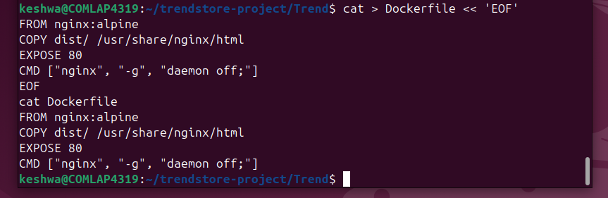
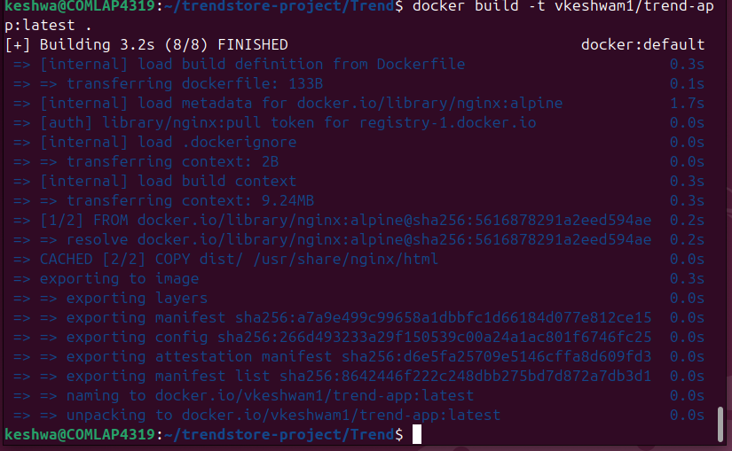
Docker Output:
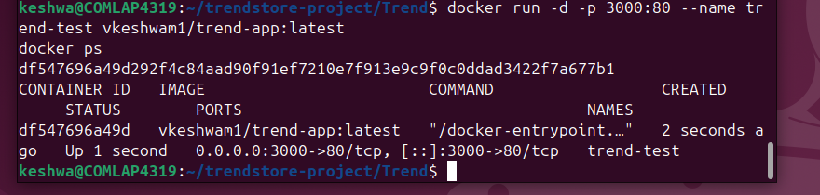
http://localhost:3000
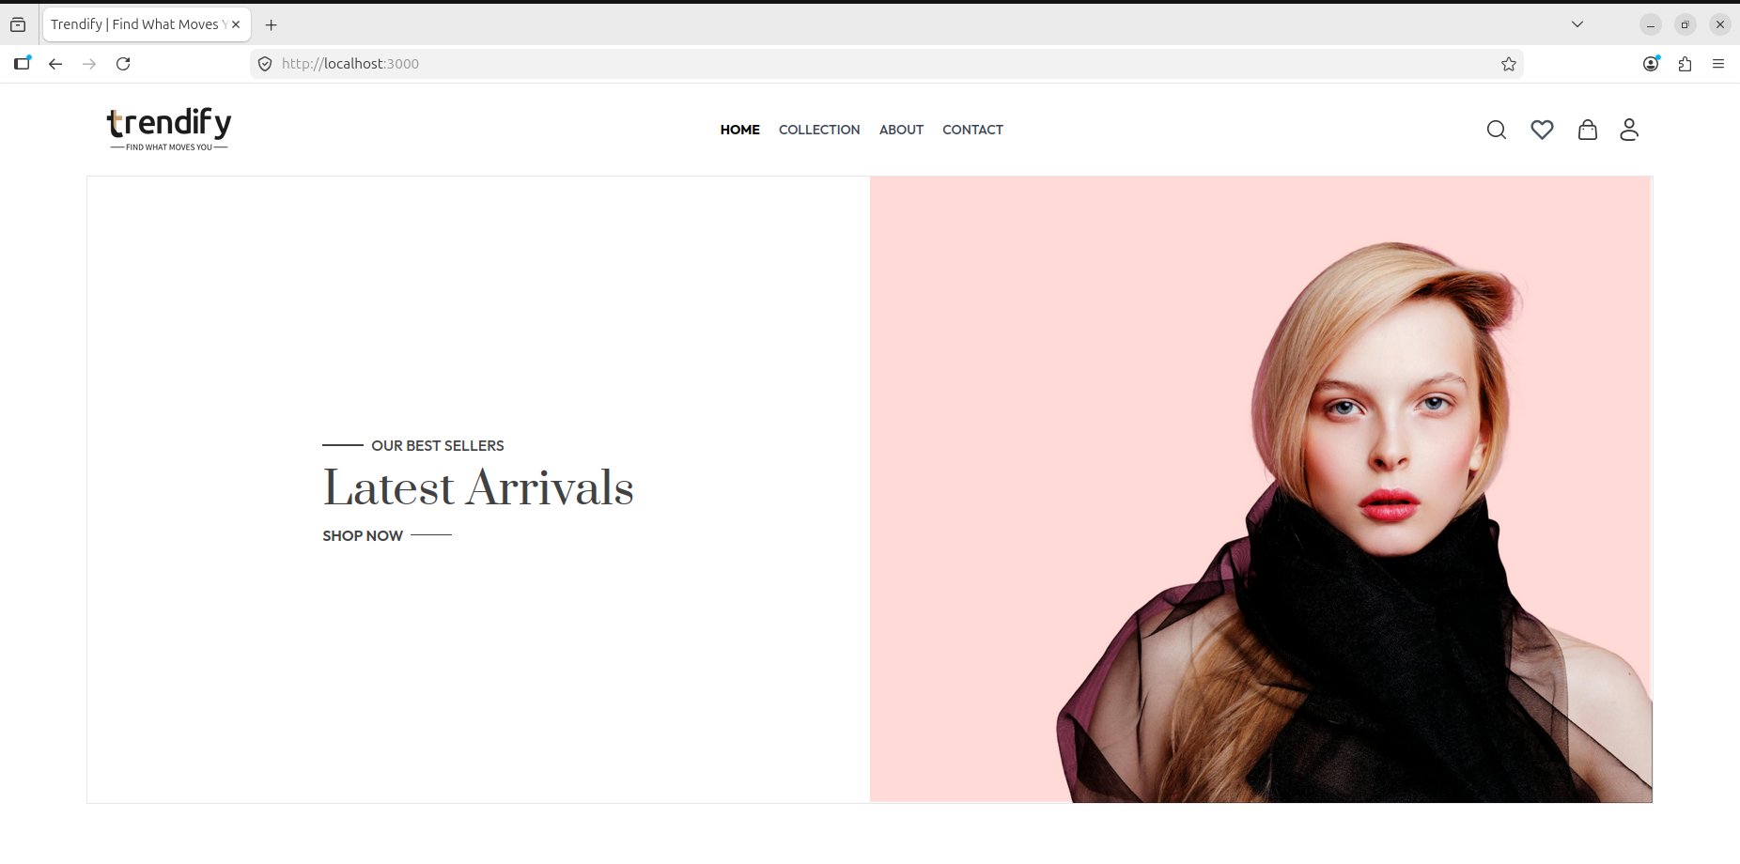
Docker login details
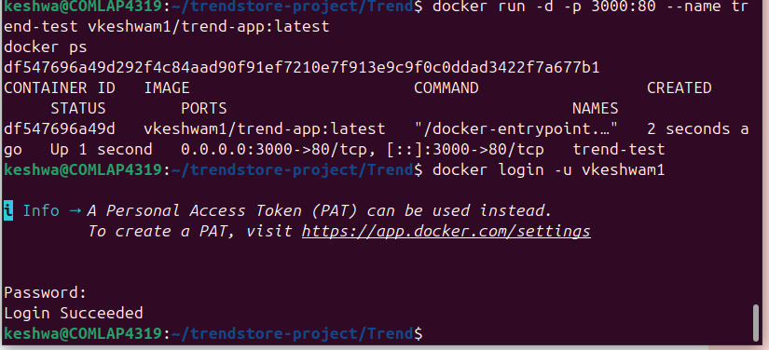
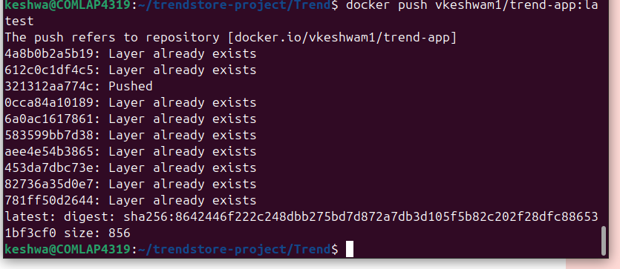
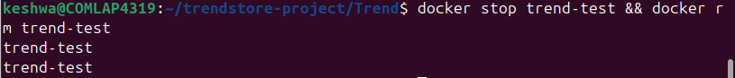
CreatingK8 file
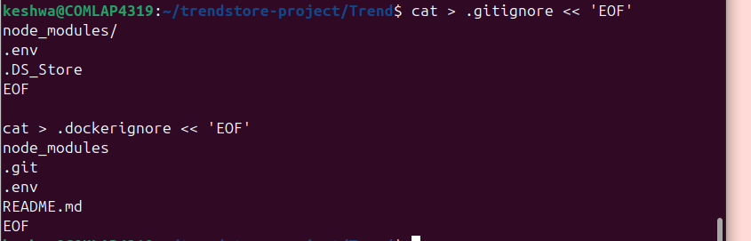
mkdir -p k8s

cat > k8s/deployment.yaml << 'EOF'
apiVersion: apps/v1
kind: Deployment
metadata:
name: trend-app
spec:
replicas: 2
selector:
matchLabels:
app: trend-app
template:
metadata:
labels:
app: trend-app
spec:
containers:
- name: trend-app
image: vkeshwam1/trend-app:latest
ports:
- containerPort: 80
EOF

cat > k8s/service.yaml << 'EOF'
apiVersion: v1
kind: Service
metadata:
name: trend-app-service
spec:
selector:
app: trend-app
ports:
- protocol: TCP
port: 80
targetPort: 80
type: LoadBalancer
EOF

ls k8s/

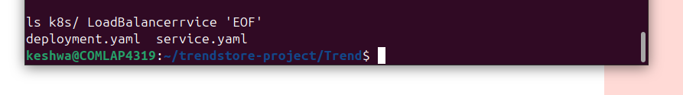
GitHub Push
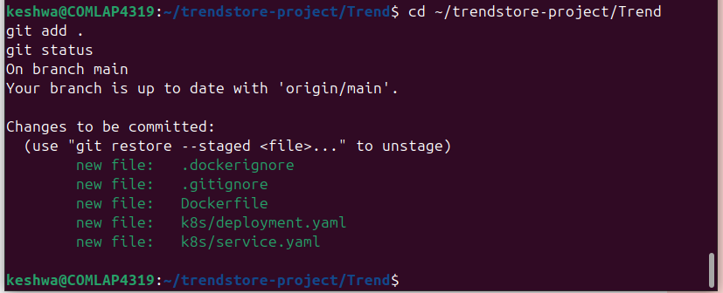
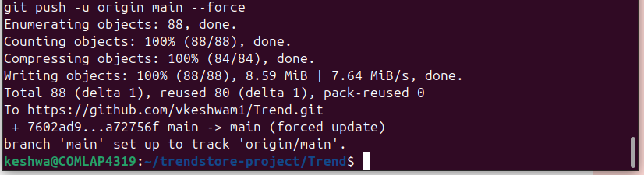
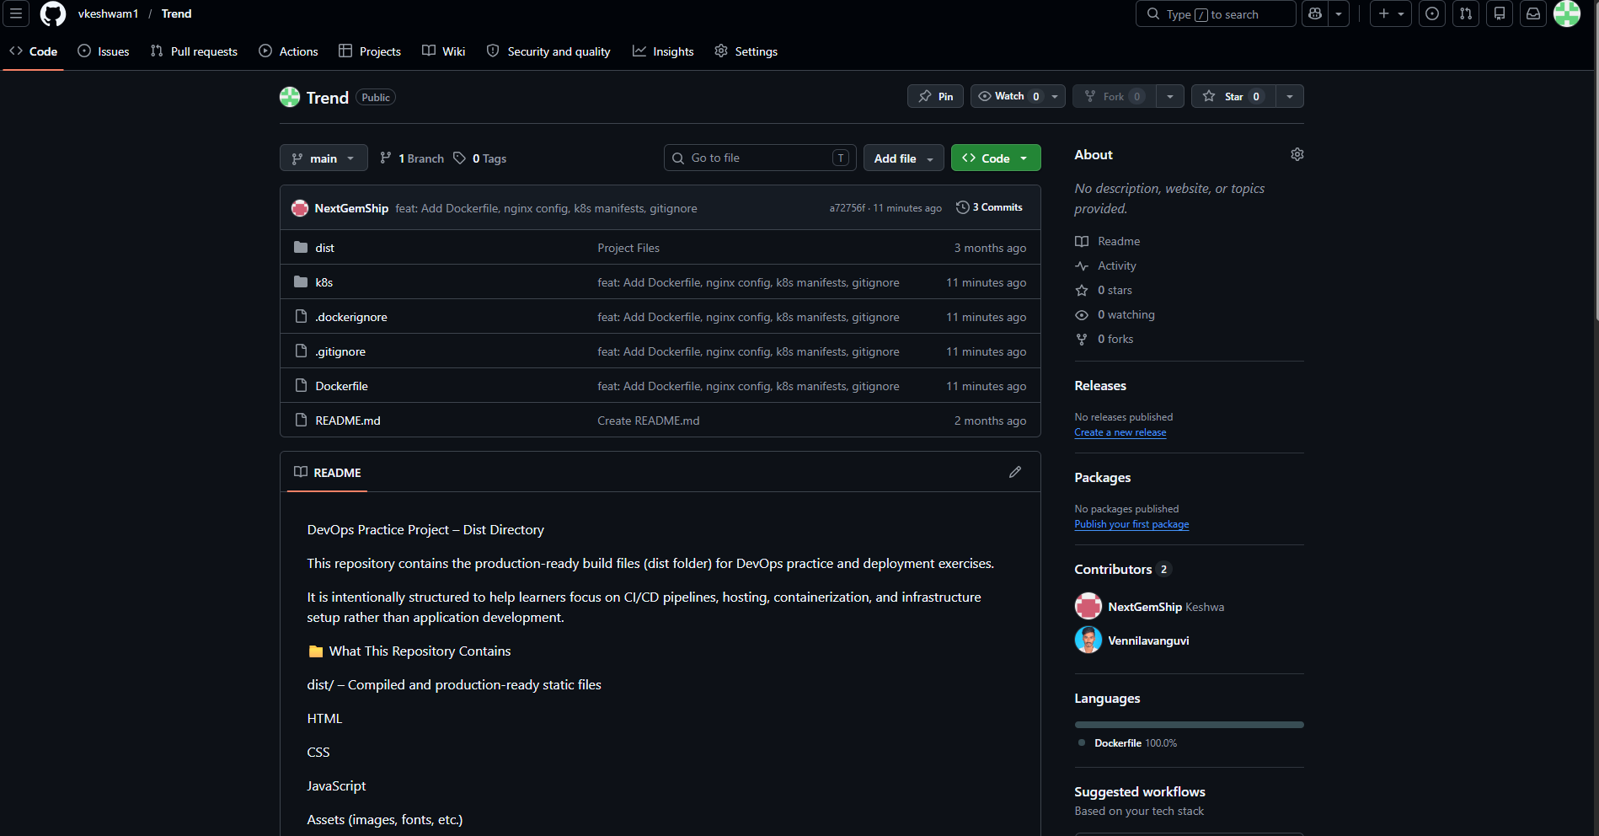
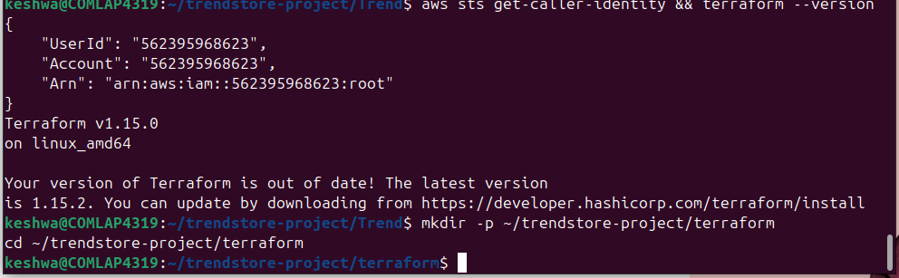
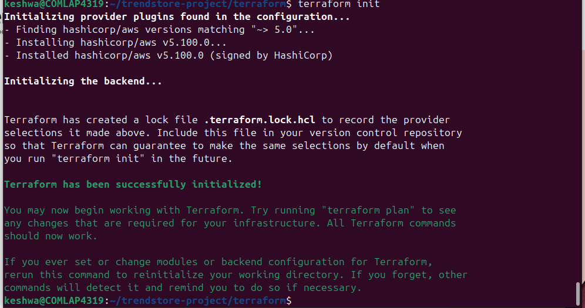

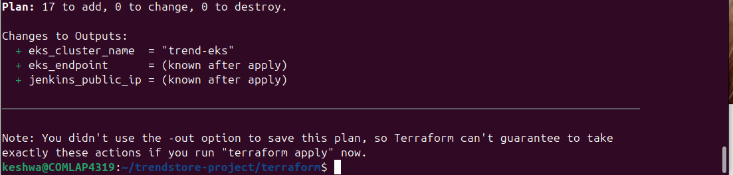
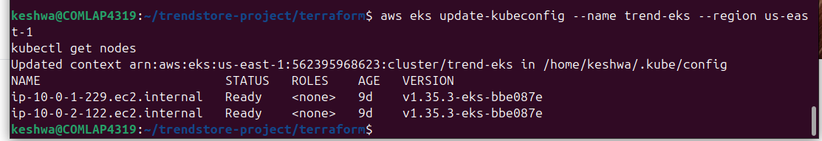
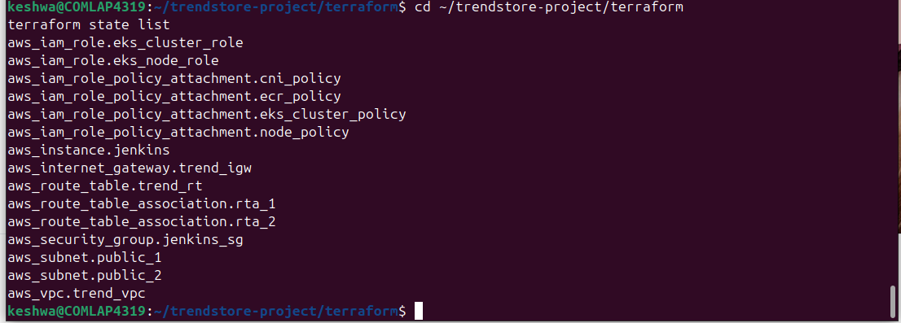

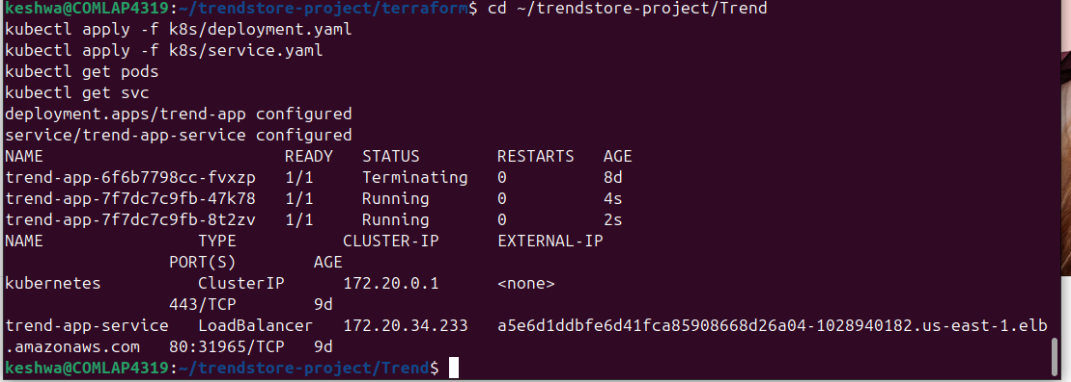
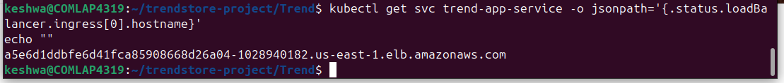
URL: http://a5e6d1ddbfe6d41fca85908668d26a04-1028940182.us-east-1.elb.amazonaws.com
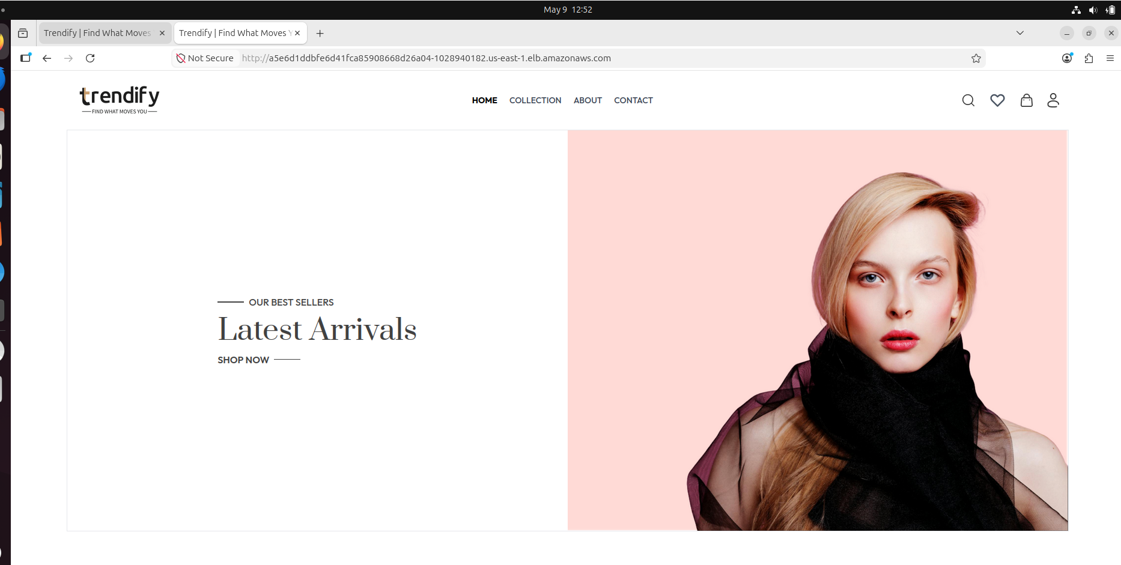
URL: https://us-east-1.console.aws.amazon.com/eks/home?region=us-east-1#/clusters
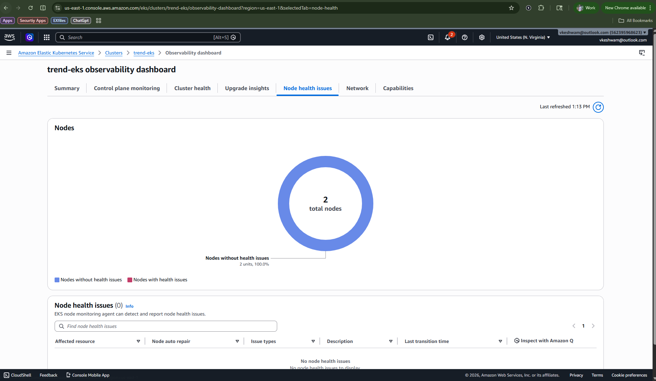

Terraform Ip: 50.17.139.255
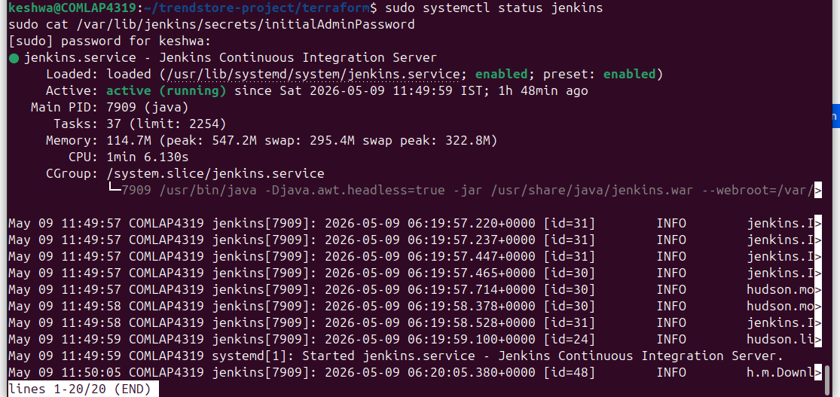

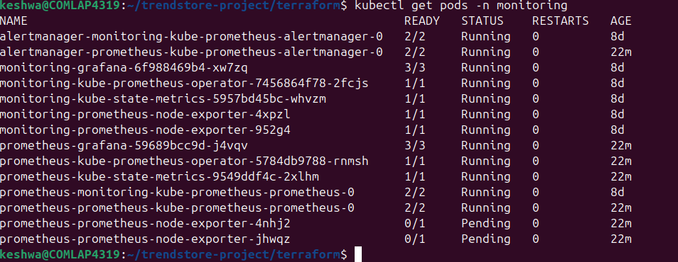
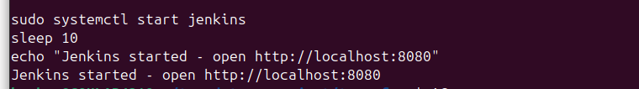

pipeline {
agent any
stages {
stage('Checkout') {
steps {
echo 'Cloning TrendStore repository...'
git branch: 'main', url: 'https://github.com/vkeshwam1/Trend.git'
}
}
stage('Docker Build') {
steps {
echo 'Building Docker image...'
sh 'docker build -t vkeshwam1/trend-app:latest .'
sh 'docker images | grep trend-app'
}
}
stage('Deploy to EKS') {
steps {
echo 'Deploying to EKS...'
sh 'kubectl apply -f k8s/deployment.yaml'
sh 'kubectl apply -f k8s/service.yaml'
sh 'kubectl get pods'
sh 'kubectl get svc'
}
}
}
post {
success { echo 'Deployment SUCCESS!' }
failure { echo 'Deployment FAILED!' }
}
}
